1.Step 1: Start

Step 2: Declare variables n1, n2, avg

Step 3: Read values of n1 and n2

Step 4: Add n1, n2 and divide them with 2

avg=n1+n2/2

Step 5: Store the value in variable avg

Step 6: Print the value of variable avg

Step 7: Stop

**Display avg**

**STOP**

**Avg← n1+n2/2**

**Read n1 and n2**

**Declare variables n1, n2, avg**

**START**

2.Step 1: Start

Step 2: Declare variables days, total fine

Step 3: Declare floating constant fine= 0.20

Step 4: Read values of days

Step 5: Multiplydays with fine

total fine ←days * fine

Step 6: Store the value in total fine

Step 7: Print the value of total fine

Step 8: Stop

**START**

**Declare variables days, total fine**

**Declare floating constant fine= 0.20**

**Read values of days**

**total fine ←days * fine**

**Display output total fine**

**STOP**

4.Step 1: Start

Step 2: Declare three variable a, b, c

Step 3: Compare a with b and c. If a is smaller than b and c than a is smallest among three numbers

Step 4: Compare b with a and c. if b is smaller than a and c than b is smallest among three numbers

Step 5: Else c is smallest among three numbers

Step 7: Stop

Read A,B,C

Is A>B

No Yes

Is A>C

Is B>C

Yes No No Yes

C is Small

A is Small

B is Small

5.Step 1: Start

Step 2: Enter the value of a, b and c

Step 3: After getting these values, the program calculates the value of discriminant, dis= b2-4ac

Step 4: It checks the value of discriminant whether it is less than zero or greater than zero

Step 5: If the dis< 0, the roots are imaginary

r1 = -b/2a +√dis*i/2a  
 r1 = -b/2a -√dis*i/2a

Step 6: Otherwise, there exist two real roots: r1 and r2

r1 = (-b + √dis)/2   
 r2 = (-b – √dis)/2

Step 7: displays the roots as output

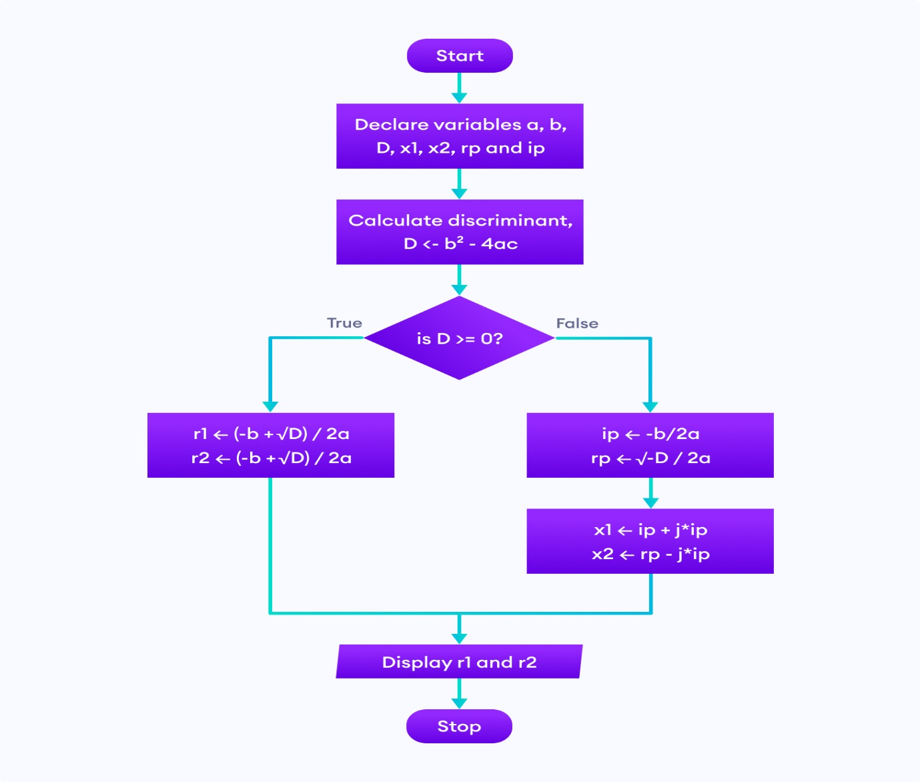 Step 8: Stop

6.Step 1. Start  
 Step 2. Read the number n  
 Step 3. i=1, fact=1  
 Step 4. Repeat step 4 through 6 until i=n  
 Step 5. fact=fact*i  
 Step 6. i=i+1  
 Step 7. Print fact  
 Step 8. Stop

Read n

I=1

Fact=1

If i<=n

False

I=i+1

Print fact

Fact=fact*i

3.Step 1. Start

Step 2. Declare variable cost=29.20,discount=0.15

Step 3. Declare variable mainprice,i

Step 4. i=discount*cost

Step 5. Mainprice=cost-i

Step 6. Store mainprice

Step 7.print mainprice

Step . Stop

Print mainprice

Mainprice=cost-i

I=discount*cost

Declare mainprice,i

Cost=29.20

Discount=0.15